FULL STACK DEVELOPMENT
Lab Exercise-1: Develop a responsive webpage layout using Tailwind CSS

1. Source Code (index.html)
<!DOCTYPE html>
<html lang="en" class="scroll-smooth">

<head>
<meta charset="UTF-8">
<meta name="viewport" content="width=device-width, initial-scale=1.0">
<title>CampusNav</title>

<link rel="preconnect" href="https://fonts.googleapis.com">
<link rel="preconnect" href="https://fonts.gstatic.com" crossorigin>
<link href="https://fonts.googleapis.com/css2?family=Inter:wght@300;400;600;800&display=swap" rel="stylesheet">

<script src="https://cdn.tailwindcss.com?plugins=typography"></script>

<script>
tailwind.config = {
theme: {
extend: {
fontFamily: {
sans: ['Inter', 'sans-serif'],
},
colors: {
brand: {
50: '#eff6ff',
100: '#dbeafe',
500: '#3b82f6',
600: '#2563eb',
900: '#1e3a8a',
}
}
}
}
}
</script>
</head>

<body
class="flex flex-col min-h-screen bg-slate-50 text-slate-800 font-sans antialiased selection:bg-brand-500 selection:text-white">

<header class="sticky top-0 z-50 bg-white/70 backdrop-blur-md border-b border-slate-200">
<div class="container max-w-7xl mx-auto px-6 py-3 flex justify-between items-center">
<a href="index.html" class="flex items-center space-x-2 group cursor-pointer">
<img src="logo.png" alt="CampusNav Logo"
class="h-10 w-auto group-hover:scale-105 transition-transform" />
<h1 class="text-xl font-extrabold tracking-tight text-slate-900">CampusNav</h1>
</a>

<nav class="hidden md:flex items-center space-x-6 font-semibold text-base text-slate-600">
<a href="index.html" class="hover:text-brand-600 transition-colors">Home</a>
<a href="#features" class="hover:text-brand-600 transition-colors">Features</a>
<a href="#documentation" class="hover:text-brand-600 transition-colors">Documentation</a>
<a href="#contactus" class="hover:text-brand-600 transition-colors">Contact Us</a>
<div class="flex items-center space-x-4 pl-4 border-l border-slate-200">
<a href="login.html"
class="text-slate-600 hover:text-brand-600 px-3 py-1.5 text-md rounded-xl hover:bg-brand-50 transition-all duration-300">Login</a>
<a href="#"
class="bg-brand-600 text-white px-5 py-2 text-md rounded-xl shadow-[0_4px_14px_0_rgb(37,99,235,0.39)] hover:shadow-[0_6px_20px_rgba(37,99,235,0.23)] hover:bg-brand-500 transition-all duration-300 transform hover:-translate-y-0.5">Sign
Up</a>
</div>
</nav>

<button id="mobile-menu-btn" class="md:hidden text-slate-600 hover:text-brand-600 focus:outline-none">
<svg class="w-7 h-7" fill="none" stroke="currentColor" viewBox="0 0 24 24">
<path stroke-linecap="round" stroke-linejoin="round" stroke-width="2" d="M4 6h16M4 12h16M4 18h16">
</path>
</svg>
</button>
</div>

<div id="mobile-menu"
class="md:hidden hidden bg-white/95 backdrop-blur-md border-t border-slate-200 absolute w-full left-0 top-full shadow-lg">
<nav class="flex flex-col px-6 py-6 space-y-4 font-semibold text-lg text-slate-600">
<a href="index.html" class="hover:text-brand-600 transition-colors">Home</a>
<a href="#features" class="hover:text-brand-600 transition-colors">Features</a>
<a href="#documentation" class="hover:text-brand-600 transition-colors">Documentation</a>
<a href="#contactus" class="hover:text-brand-600 transition-colors">Contact Us</a>
<hr class="border-slate-200 my-2">
<div class="flex flex-col space-y-4 pt-2">
<a href="login.html"
class="text-slate-600 hover:text-brand-600 px-4 py-2 text-center rounded-xl hover:bg-brand-50 transition-all duration-300 border border-slate-200">Login</a>
<a href="#"
class="bg-brand-600 text-white px-6 py-2.5 text-center rounded-xl shadow-[0_4px_14px_0_rgb(37,99,235,0.39)] hover:bg-brand-500 transition-all duration-300">Sign
Up</a>
</div>
</nav>
</div>
</header>

<main class="flex-grow">

<section
class="relative overflow-hidden bg-gradient-to-b from-brand-50 to-white pt-8 pb-10 border-b border-slate-100">
<div
class="absolute top-0 right-0 -mr-20 -mt-20 w-80 h-80 rounded-full bg-brand-100 blur-3xl opacity-50 pointer-events-none">
</div>

<div
class="container max-w-7xl mx-auto px-6 relative z-10 flex flex-col md:flex-row items-center justify-between">

<div class="md:w-1/2 text-center md:text-left mb-8 md:mb-0 pr-0 md:pr-4">
<h2 class="text-3xl xl:text-5xl font-extrabold text-slate-900 mb-4 leading-tight tracking-tight">
Navigate Your Day <br class="hidden md:block" />
<span
class="text-transparent bg-clip-text bg-gradient-to-r from-brand-600 to-indigo-600">Uninterrupted</span>
</h2>
<p class="text-base text-slate-600 mb-6 max-w-md mx-auto md:mx-0">
The ultimate intelligent routing engine. Find the absolute shortest path across campus.
</p>

</div>

<div class="md:w-1/2 max-w-xl relative mx-auto md:mx-0">
<div
class="absolute inset-0 bg-gradient-to-tr from-brand-200 to-indigo-200 rounded-2xl transform rotate-3 scale-105 opacity-50 blur-lg">
</div>
<div class="relative bg-white p-2 rounded-2xl shadow-2xl border border-slate-100">
<img src="AR_Campus.png" alt="Map Interface Preview"
class="rounded-xl w-full h-auto object-cover aspect-video" />
</div>
</div>
</div>
</section>

<section id="features" class="scroll-mt-16 pt-12 pb-16 bg-white">
<div class="container max-w-7xl mx-auto px-6">
<div class="grid grid-cols-1 md:grid-cols-3 gap-6">

<div class="p-5 bg-slate-50 rounded-2xl border border-slate-100 hover:shadow-md transition-shadow">
<div
class="w-10 h-10 bg-indigo-100 text-indigo-600 rounded-xl flex items-center justify-center mb-4">
<svg class="w-5 h-5" fill="none" stroke="currentColor" viewBox="0 0 24 24">
<path stroke-linecap="round" stroke-linejoin="round" stroke-width="2"
d="M13 10V3L4 14h7v7l9-11h-7z"></path>
</svg>
</div>
<h3 class="text-lg font-bold text-slate-900 mb-2">Algorithmic Routing</h3>
<p class="text-sm text-slate-600">Powered by Dijkstra's shortest-path algorithm running on a
Node.js
backend to guarantee the fastest route possible.</p>
</div>

<div class="p-5 bg-slate-50 rounded-2xl border border-slate-100 hover:shadow-md transition-shadow">
<div
class="w-10 h-10 bg-emerald-100 text-emerald-600 rounded-xl flex items-center justify-center mb-4">
<svg class="w-5 h-5" fill="none" stroke="currentColor" viewBox="0 0 24 24">
<path stroke-linecap="round" stroke-linejoin="round" stroke-width="2"
d="M17.657 16.657L13.414 20.9a1.998 1.998 0 01-2.827 0l-4.244-4.243a8 8 0 1111.314 0z">
</path>
<path stroke-linecap="round" stroke-linejoin="round" stroke-width="2"
d="M15 11a3 3 0 11-6 0 3 3 0 016 0z"></path>
</svg>
</div>
<h3 class="text-lg font-bold text-slate-900 mb-2">Live Geolocation</h3>
<p class="text-sm text-slate-600">Utilizes HTML5 Geolocation APIs to track your exact position
and
dynamically recalculate paths if you take a wrong turn.</p>
</div>

<div class="p-6 bg-slate-50 rounded-2xl border border-slate-100 hover:shadow-md transition-shadow">
<div
class="w-10 h-10 bg-rose-100 text-rose-600 rounded-xl flex items-center justify-center mb-4">
<svg class="w-5 h-5" fill="none" stroke="currentColor" viewBox="0 0 24 24">
<path stroke-linecap="round" stroke-linejoin="round" stroke-width="2"
d="M12 18h.01M8 21h8a2 2 0 002-2V5a2 2 0 00-2-2H8a2 2 0 00-2 2v14a2 2 0 002 2z">
</path>
</svg>
</div>
<h3 class="text-lg font-bold text-slate-900 mb-2">Mobile Optimized</h3>
<p class="text-sm text-slate-600">Built as a React Single Page Application with Tailwind CSS,
ensuring
high-contrast visibility when walking outside.</p>
</div>

</div>
</div>
</section>

<section id="documentation" class="scroll-mt-16 pt-12 pb-16 bg-slate-50">
<div class="container max-w-6xl mx-auto px-6">
<article
class="prose prose-slate prose-md mx-auto bg-white p-10 md:p-12 rounded-3xl shadow-sm border border-slate-200">
<h2 class="text-2.5xl font-bold text-slate-900">System Architecture</h2>
<p class="lead text-base text-slate-600">
The Campus Navigation System is engineered to optimize student commutes and eliminate
navigational friction across complex university grounds.
</p>
<hr class="my-6 border-slate-200" />
<h3 class="text-2xl font-bold text-slate-800">Database Models</h3>
<p class="text-md">
We leverage MongoDB's powerful spatial querying capabilities. Building locations and pathways
are stored as GeoJSON objects, utilizing <code>2dsphere</code> indexing to allow for rapid
proximity calculations.
</p>
<pre class="bg-slate-800 text-slate-50 rounded-xl p-4 overflow-x-auto"><code>// Sample Node Schematic
{
"name": "Science Building",
"location": {
"type": "Point",
"coordinates": [-73.935242, 40.730610]
}
}</code></pre>
<h3 class="text-2xl font-bold text-slate-800">API Interactivity</h3>
<p class="text-md">
The Express server exposes a RESTful API. When the React client submits a start and end
destination, the backend executes our custom pathfinding middleware, returning an ordered array
of coordinate waypoints to render the polyline on the frontend map.
</p>
</article>
</div>
</section>

</main>

<footer class="bg-slate-900 text-slate-400 py-6 border-t border-slate-800">
<div class="container max-w-8xl mx-auto px-20 grid grid-cols-1 md:grid-cols-5 gap-6">

<div class="md:col-span-2">
<div class="flex items-center space-x-2 mb-4">
<svg class="w-8 h-8 text-brand-500" fill="none" stroke="currentColor" viewBox="0 0 24 24">
<path stroke-linecap="round" stroke-linejoin="round" stroke-width="2"
d="M9 20l-5.447-2.724A1 1 0 013 16.382V5.618a1 1 0 011.447-.894L9 7m0 13l6-3m-6 3V7m6 10l4.553 2.276A1 1 0 0021 18.382V7.618a1 1 0 00-.553-.894L15 4m0 13V4m0 0L9 7">
</path>
</svg>
<h3 class="text-white text-xl font-bold tracking-tight">CampusNav</h3>
</div>
<p class="text-sm max-w-sm leading-relaxed">An open-source initiative to make campus navigation
accessible, efficient,
and data-driven. Built with the MERN stack.</p>
</div>

<div id="contactus" class="flex flex-col space-y-4 text-base">
<h4 class="text-white text-md font-semibold mb-1">Contact Us</h4>
<p class="text-sm max-w-sm leading-relaxed">Phone : 8523645972 <br> Email : info@campusnav.com</p>
</div>

<div class="flex flex-col space-y-4 text-base">
<h4 class="text-white text-md font-semibold mb-1">Resources</h4>
<a href="#" class="text-sm hover:text-white transition-colors">GitHub Repository</a>
<a href="#" class="text-sm hover:text-white transition-colors">API Documentation</a>
<a href="#" class="text-sm hover:text-white transition-colors">Deployment Guide</a>
</div>

<div class="flex flex-col space-y-4 text-base">
<h4 class="text-white text-md font-semibold mb-1">Legal</h4>
<a href="#" class="text-sm hover:text-white transition-colors">Privacy Policy</a>
<a href="#" class="text-sm hover:text-white transition-colors">Terms of Service</a>
<a href="#" class="text-sm hover:text-white transition-colors">Data Collection</a>
</div>

</div>
<div
class="container mx-auto px-6 pt-8 mt-8 border-t border-slate-800 text-sm flex flex-col md:flex-row justify-between items-center">
<p>&copy; 2026 Campus Navigation System. All rights reserved.</p>
</div>
</footer>

<script>
const btn = document.getElementById('mobile-menu-btn');
const menu = document.getElementById('mobile-menu');

btn.addEventListener('click', () => {
menu.classList.toggle('hidden');
});

const mobileLinks = menu.querySelectorAll('a');
mobileLinks.forEach(link => {
link.addEventListener('click', () => {
menu.classList.add('hidden');
});
});
</script>
</body>

</html>

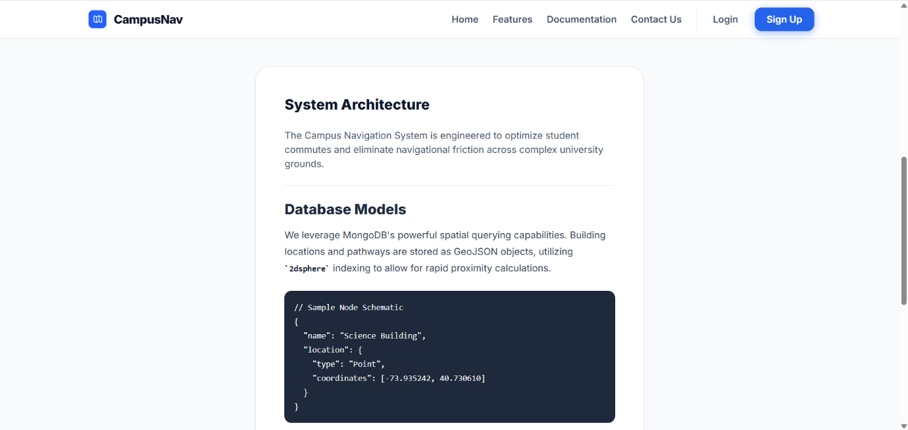
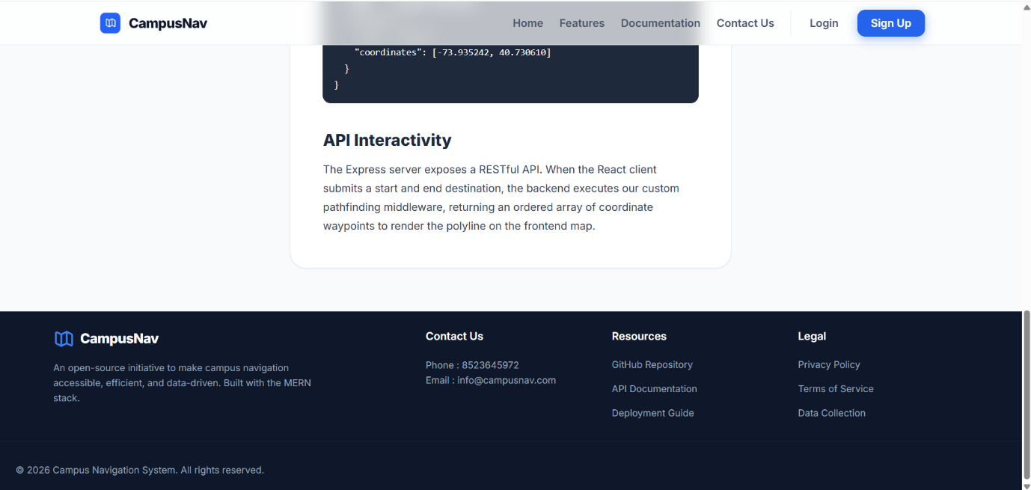
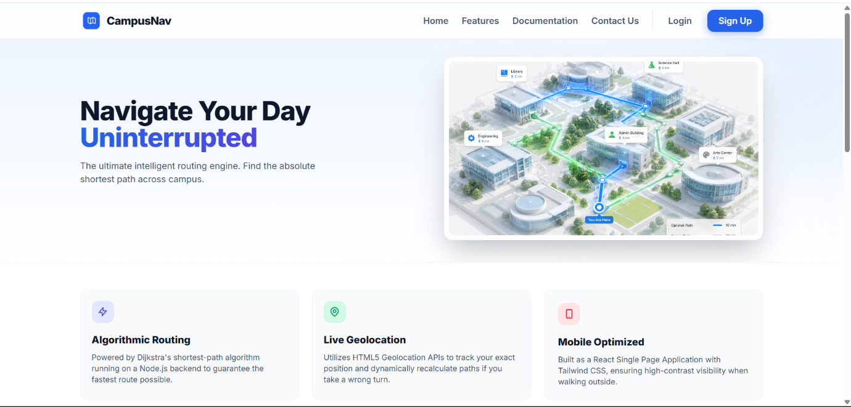
2. Screenshots (Landing page)
3. GitHub Repository Link (GitHub Repository URL)
GitHub Link: https://github.com/GTAPRO7/FSD_LAB
Live Deployment: https://gtapro7.github.io/FSD_LAB/
4. AI Usage Declaration (AI Tools and Purpose of usage)
AI Used: Google Gemini
Usage:
In the process of creation of this project, AI systems were used as an aid tool for researching, generating ideas, and creating references. In particular, AI systems were employed for idea generation for the project, building a base structure, obtaining references for technical details, such as the MERN stack architecture, and creating the first basic structural content. All the recommendations of the AI were verified and incorporated according to project needs.

